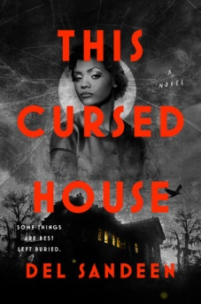


This Cursed House by Del Sandeen
Meeting date: Thursday, April 24th, 2025
Time: 7 p.m.

Discussion Questions
1. If Jemma’s adoptive father had been accepting of and loving toward her, do you think she would have approached her relationship to the Duchons differently?
2. The Duchon family has been trapped on their property for decades, and they’re also under a death curse. In what other ways are they cursed?
3. What lessons does Magdalene teach Jemma?
4. Forgiveness is an important theme of the book. Do you think that forgiving someone is the best way to free yourself from anger and other
emotions, or do you believe that there are more effective ways for one to find emotional freedom?
5. If this book were set in the present day, would the issue of colorism still be relevant? Why or why not?
6. What do you think of Inès’s decision to stay and continue to act as her family’s housekeeper once her binding curse is broken? Why do you think she remains in this role instead of leaving the house immediately?
7. Do you believe Jemma’s leaving New Orleans is the right choice? If her mother and Dennis were to stay behind, and as a result Jemma were
to stay, what type of life do you think she might have? Do you think Jemma and the Duchons could maintain a relationship?
8. What do you think the Duchons’ lives will be like after Jemma leaves for California? Do you think any of them has the potential to truly change? If so, who? And how?
9. Both Jemma and Inès can see ghosts, but they choose to ignore them. How does their choice to do so negatively impact their lives?
10. At the end of the book, when Jemma introduces herself by her birth name, what do you think it means in terms of her acceptance of herself and what she will do going forward?

