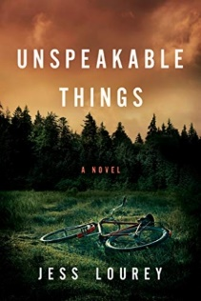
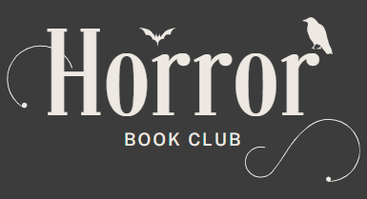

Unspeakable Things by Jess Lourey
Meeting date: Thursday, May 22nd, 2025
Time: 7 P.M.

Discussion Questions
- The book is told from the perspective of 12-year-old Cassie and can be seen both as a thriller/mystery and a coming of age story. How engaged were you with those elements? Did one take precedence over the other? Did you find yourself reading to see how the mystery turned out, or how Cassie grew up?
- How important is the setting to the story? We don’t see that many mystery/thrillers taking place in settings so close to us - how does it add or detract from the reading experience?
- “Unspeakable Things,” although entirely fictional, is inspired by the author growing up in Paynesville, MN in the 1980s. During that time 8 local boys were abducted and released, and years later a blogger connected those abductions with the disappearance of Jacob Wetterling. What do you remember of the Jacob Wetterling case? Had you heard about the 8 boys abducted and released before that? Does knowledge of those real-life events influence your reaction to the book?
- Discuss the mystery/thriller elements of the plotline. Can you identify plot twists and red herrings? How effective are they? Were you able to predict what would happen or did you keep guessing until the end? How did that affect your appreciation of the book?
- The author has an epilogue that was not printed with the book but is available on her website http://jessicalourey.com/survey-two. She wanted people to be able to imagine futures for the characters themselves. Did you do that? What did you see in their future? Or would you have preferred to have the author’s epilogue included in the book?
- What is the most important element of a book to each person: characterization, action, dialogue, or setting? How do you think Lourey did with each of these elements? Were some stronger than others?
- Do you have a favorite character, and if so, why? Were character motivations believable or did they seem to just be there to move the plot forward?
- Being from the same general area, we have a sense of how people talk around here. Does the dialogue ring true? Did any of the language seem jarring or out of place? And if so, did it serve a purpose?
- What did you like or dislike about the book that hasn’t been discussed yet?
- Would you recommend this book to somebody else? Why or why not?

