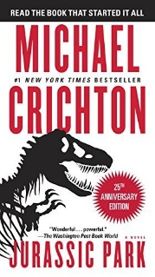
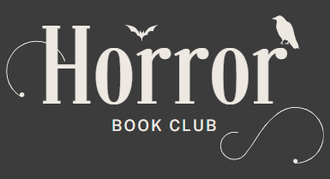

Jurassic Park by Michael Crichton
Meeting date: Thursday, July 24th, 2025
Time: 7 P.M.

Discussion Questions
- What were the main causes of Jurassic Park?
- Do you think it could have been possible to make Jurassic Park safe?
- Do you think the disaster and the bombing of the park could have been avoided?
- Was Nedry's death inevitable because of his greed?
- Do you think that Hammond really cared about taking the world of science to a new level?
- Would it have been possible for the park to work if it had a different extinct species?
- Could the park have worked if it wasn't propelled by Hammond's greed?
- If the dinosaurs weren't violent, would the park have succeeded?
- What was the main flaw with Jurassic Park?
- Do you think that Hammond would have still wanted the park if it didn't have carnivores?

