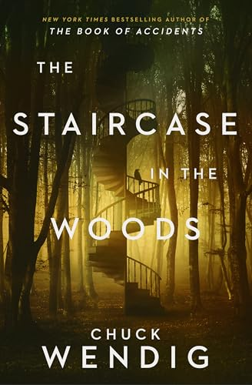
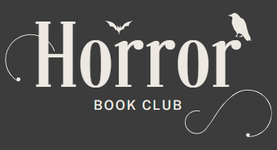

The Staircase in the Woods by Chuck Wendig
Meeting date: Thursday, November 20th, 2025
Time: 7 p.m.

Discussion Questions
- Matty, Lore, Owen, Nick, and Hamish all became friends in high school, where their bond was so strong they swore to the Covenant. What drew such different people together? Why do you think the friendships we form as children and teens are so powerful?

- We see the characters as high schoolers, then again as adults. What do you make of the ways they have all changed? In what ways are you different from or the same as your teenage self?

- Which character is your favorite? Who do you find yourself identifying with the most?

- When they first encounter the staircase, Matty is the only friend to walk up the stairs. Why do you think he was the one to try walking up the stairs? Would you have made the same decision to explore what lies beyond the staircase?

- The characters were teens in the ’90s and have a lot of free rein to be outside of their homes with limited oversight from adults and family. In your experience, is this different from how teens are allowed to move in the world now (or from when you were a teen). If so, to what do you attribute this difference?

- Lore’s background as a game designer leads her to interpret the house as a game. In what ways is the house both like and unlike a video game? How would you go about solving the puzzle it presents?

- In the house, the friends all encounter visions and sights that terrify them but also reveal something about them. What do we learn about who each character really is by what they see in the house? What did you find most frightening in the house? How would you react to being in the same situation?

- The relationship between Lore and Owen is one of the most fraught but also becomes one of the most intimate. Why were they able to resolve their differences? What does it mean to forgive a friend, and how does time affect our ability to forgive them?

- In chapter 66, Lore has a memorable monologue about how “friendship is like a house.” What do you make of her statement, and what about it resonated with you?

- The ending of the book is somewhat ambiguous. Why do you think the author chose to end the book this way?

