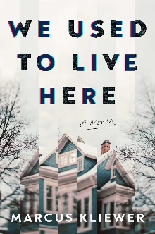
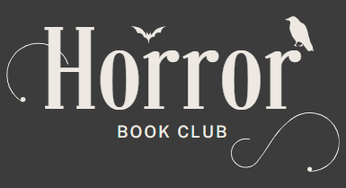

We Used to Live Here by Marcus Kliewer
Meeting date: Thursday, October 23rd, 2025
Time: 7 P.M.

Discussion Questions
1. Kliewar uses many familiar horror tropes, from characters like the bumbling protagonist and their dubious partner, to props like unreliable flashlights and light switches that don't turn on. In what ways did this horror story feel familiar to you? What elements felt fresh or novel?
2. How does the author build and maintain a sense of dread throughout the novel? Which scenes or imagery did you find most unsettling?'
3. How does Kliewar play with the theme of perception versus reality? How does Eve's role as an unreliable narrator play into this?
4. What impact do the interspersed newspaper articles, police interviews, notes and transcripts have? How do they contribute to the story? Did they make it feel more real for you?
5. The end of the story leaves many unanswered questions. Did you like this open to interpretation ending, or did you want to have things more neatly tied up?
6. What's your hypothesis as to what was going on in the novel? What support or evidence do you have for it? Make your case!
7. Did you translate the morse code at the end of each research section? If so, did the resulting sentence change any of your theories about what was happening at the house?
8. What are some of your most burning remaining questions after finishing the book? Would you want Kliewar to write a sequel to address them?

